POWYS COUNTY COUNCIL
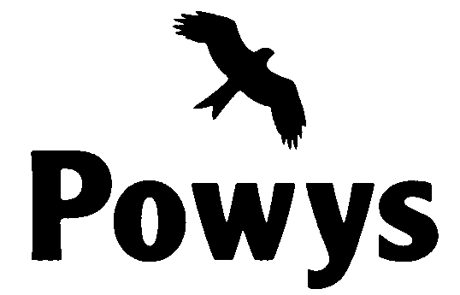

APPLICATION FOR FREE SCHOOL MEALS 2015/16

(including WELSH GOVERNMENT YEAR 7 SCHOOL CLOTHING GRANT SCHEME)
ALL SECTIONS OF THIS FORM SHOULD BE COMPLETED BY THE PARENT/GUARDIAN CLAIMING THE BENEFIT BELOW

Your Forename ______________________________ Surname ___________________________________________

Relationship to pupil/s ________ National Insurance No. :

Date of Birth: __________________

Partner’s Forename ___________________________ Surname ___________________________________________

Date of Birth: ___________________ National Insurance No. :

Address:

Postcode: Tel. No. :

Set out below the details of each dependant child for whom you are applying i.e. for whom you receive Child Benefit, who is/are living at home and is/are in full-time attendance at school. Do not include on your application any fostered children.
Name | Male/Female | Date of Birth | School Attending

ELIGIBILITY CRITERIA (please which benefit you are receiving):

□Income Support (IS) □ Income-based Job Seekers Allowance (IBJSA) □Guarantee element of State Pension Credit

□Support under Part VI of the Immigration and Asylum Act, 1999 □Employment Support Allowance (Income Related) (ESA(IR)

□Entitled to Child Tax Credit but not Working Tax Credit with annual taxable income up to £16,190 Universal Credit

CLOTHING GRANT: Please complete the below so that we can make a payment direct into your bank account
Name of Bank | Sort Code |  |  | Account No.

The Council will, for all applicants for Free School Meals, check the entitlement to Free School Meals through the use of the Department for Education Eligibility Checking Service (ECS) database, and will only ask for evidence from the applicant if the information on the database does not confirm entitlement or to confirm the dates of entitlement for arrears or repayments.

I understand that the information I have given is to be held by the Council subject to the provisions of the Data Protection Act 1998 as may be amended, updated or replaced from time to time, and that the information given on this form will be used for the purposes of processing my free school meals application.

I certify that the information given above is, to the best of my knowledge and belief, correct.

I undertake to advise the Council immediately of any change in my circumstances (Tel No: 0845 602 7032 / E-mail: benefits@powys.gov.uk).

I agree that you will use the information I have provided to process my claim for free school meals, and will contact other sources as allowed by the law to verify my entitlement. I also agree that this information may be used to provide information for any other award or benefit I may be entitled to as allowed by law.

I understand that the results of this check may also be used to assess my entitlement to a School Uniform Grant when each child for whom I am applying transfers to Year 7.

SIGNATURE OF APPLICANT DATE

The Council is under a duty to protect public funds it handles and may use the information provided on this form to prevent and detect fraud and may also share this information, for the same purposes, with other organisations which handle public funds.

PLEASE RETURN THIS FORM TO:
Income and Awards Service, County Hall, Llandrindod Wells, Powys, LD1 5LG
Unless this form is completed and returned your child/ren cannot be considered for free meals.
Headteachers have been instructed NOT to give free meals to any child/ren unless they have received authorisation.

