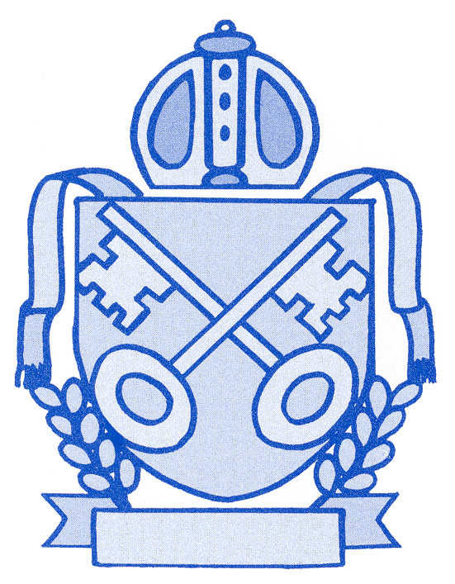 | St. Michael’s Church in Wales Primary School |  |  |  |  |   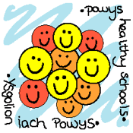    
 | Newsletter | December 2015
Welly Walk for the Farm Africa Appeal    A massive £894.75 was raised for this very worthwhile cause.  Thanks to all who donated and to Mrs Holloway for organising this fun event. |  |  | Christmas Concerts  There will be two concerts during the  Christmas period. The dates are as follows:    Foundation Phase/Infants (Classes 1, 2 and Y2 in Class 3)  Tuesday December 8th at 1.45pm in school  Thursday December 10th at 6.00 pm in school  - Please bring the children to school no earlier than 5.30 pm    KS 2 /Juniors (Class 4, 5 and Y3 in Class 3)  Monday December 7th 1.45pm in church  Wednesday December 9th 6.00pm in church  - Please bring the children to SCHOOL to get ready no earlier than 5.30 pm. School staff will take them across to the church..  - At the end the children will walk back to school where parents can pick them up  If you are not attending the concerts please make sure your child/children is/are collected from school, we will not allow any child to walk home alone.  Tickets  We are not issuing tickets this year but please only come to one performance of each concert so there are enough seats for all.

Christmas Parties
We are very grateful to the Friends of the School for once again organising parties for the children.

Infants Wed 16th December 2 -3 pm
Juniors Thurs 17th December 1.45 – 3 pm

- Children can wear their own clothes on their party day.
Please send in a contribution of £1 per child for a cake and drink. Please speak to Mrs Rachel Pughe if you can help on either afternoon.
  Raffle  We would welcome donations of raffle prizes for both Wednesday and Thursday.  As you are aware, unlike many schools we do not charge for tickets but the money we collect through the raffle and money donations is very important for the school during the year, so please give generously. |  |  |  |  | Christmas Fayre  The Christmas Fayre in the Village Hall will take place on Saturday 5th of December.    Please do your best to come along to support Classes 2, 3 and 4 who are making Rocky Road cakes.  Please come along!
  Christingle  Thurs 16th December 9.15 am  Parents, family and members of the  community are very welcome to join us  for the Christingle Service at St.  Michael’s Church. |  |  |  | Christmas Concert DVD  Mr Alan Lewis is recording the concert this year. If you would like a DVD please fill in the slip below and return it to school. They should be ready for Christmas.  The cost once again is £14.00. Please make cheques payable to St. Michael’s Primary School.

* This newsletter is available on the parents’ page on HWB+ and on the school website www.st-michaels.powys.sch.uk

_______________________________________________________________________________________________________________________________________________________
Christmas Concert DVD

We would like Christmas DVDs and enclose £___________ cash / cheque (@ £14 each)
(Please make cheques payable to St. Michael’s Primary School)

Child’s Name ________________________________ Class: __________________________________

Signed: ______________________ Print name: _______________________ Contact No. ______________

Swimming  Well done to Sarah Parry and Nell Dee reaching the second round of the Urdd Swimming Gala heats. Congratulations to Nell who came 2nd and Sarah who came 3rd. |  |   British Legion Poppy Appeal  We raised £204 this year, a very high amount for a Powys School. Once again, many thanks for donating for this worthy cause.
Abacus Maths evening  Disappointingly, very few parents attended this curriculum event for parents where teachers introduced the new Abacus Maths scheme of work that children have been using this term.  Many thanks to those who came along and to the teachers for giving up their time. |   DSchool Closure as a result of bad weather or utilities failure  A Any decision to close the school is never made lightly – the health and safety of pupils and that of staff must be taken into account. We have to consider the safety of staff in getting to and from school and we must make sure there are sufficient adults to supervise the children.  Sometimes only one or two classes may have to be closed whilst others are able to stay open – the Powys webpage http://www.powys.gov.uk/index.php?id=222&L=0  will give you this information.  Should there be snow ice or other bad weather, please check the Powys School Closure website or sign up for a text alert at www.powys.gov.uk/accounts.  - Any decision to close the school in the morning will be made by 7.45 am.  If it snows heavily during the school day, please make sure we can contact you as we may need you to fetch your child earlier than the usual pick-up time.
Sickness Bug
There is a nasty and very contagious bug going round at the moment which seems to be lasting for 72 hours. A polite reminder to you that children should not come back to school for 48hrs AFTER the last symptoms. This advice from Public Health Wales is designed to prevent the spread of such illness to other pupils and staff.

DIARY DATES

 | Sport / Trips / Activities
December
Sat 5th | Village Christmas Fayre
Mon 7th | Key Stage 2 Christmas concert - 1.45 pm in church
Tues 8th | Foundation Phase Christmas concert 1.45 pm in school
Wed 9th | Key Stage 2 Christmas concert 6.00 pm in church
Thurs 10th | Foundation Phase Christmas concert 6.00 pm in school
Wed 16th | Foundation Phase Christmas party FP wear own clothes
Thurs 17th | Christingle Service 9:15 am in St. Michael’s Church
Thurs 17th | Key Stage Two Christmas party KS2 wear own clothes
Fri 18th | End of term
January
Mon 4th | Start of new term

